UNIVERSITY OF LUCKNOW
Faculty of Engineering and Technology
Session: 2024-25

Computer Science & Engineering
Year: 3, Semester: 6

Subject: Seminar
Code:CS - 654

Seminar Report
Topic:Engineering AI: The Tools That Shape Us Are Shaped by Us

Submitted To: SubmittedBy : Er. Om Prakash Singh
Sudha Kumari
2210013135115

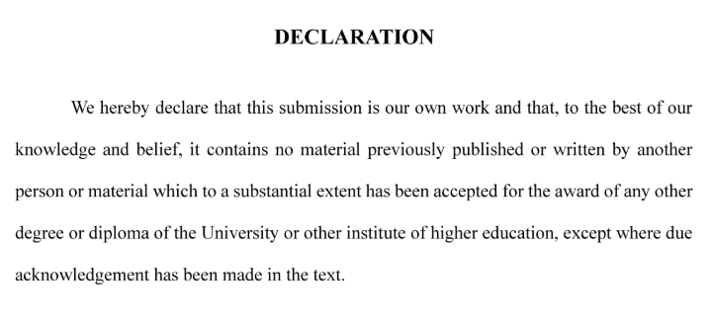

Signature
Sudha Kumari
2210013135115

Abstract
Artificial Intelligence (AI) has emerged as a transformative force in engineering, revolutionizing traditional methodologies through automation, predictive analytics, and intelligent decision-making. This report provides an in-depth examination of how AI is reshaping engineering disciplines while simultaneously being refined by engineers to address ethical and technical challenges. We explore the fundamental concepts of AI, its evolutionary trajectory in engineering applications, current technological advancements, and the dichotomy between its beneficial applications and potential risks.
The study delves into specific AI technologies such as Machine Learning (ML), Natural Language Processing (NLP), and Computer Vision, illustrating their practical implementations across various engineering domains. Comparative analyses between Data Science (DS), Deep Learning (DL), ML, and AI are presented to clarify their distinct roles and intersections.
Furthermore, the report investigates AI's portrayal in popular culture, highlighting how fictional representations often predict real-world developments. Critical discussions on the ethical implications of AI, including deepfakes, privacy violations, and job displacement, provide a balanced perspective on its societal impact.
Case studies on predictive maintenance and structural monitoring demonstrate AI's tangible benefits in enhancing efficiency and safety. Emerging trends such as quantum AI and ethical AI frameworks are examined to forecast future developments.
This comprehensive analysis concludes with insights into the symbiotic relationship between AI and engineering, emphasizing the need for responsible innovation to harness AI's full potential while mitigating its risks.

Acknowledgement
I would like to express my deepest gratitude to my esteemed teacher, for their invaluable guidance, encouragement, and expert supervision throughout the preparation of this seminar report. Their insightful feedback and constructive criticism have been instrumental in shaping the depth and quality of this research.
I am also profoundly thankful to our institution for providing access to cutting-edge resources and research materials that facilitated a comprehensive understanding of Artificial Intelligence in engineering. My sincere appreciation extends to my colleagues and peers for their stimulating discussions and moral support during this academic endeavor.
Lastly, I acknowledge the pioneering researchers and engineers whose groundbreaking work in AI has formed the foundation of this report. Their contributions continue to inspire innovation in the field.

Table of Contents
Section | Page No.
1. Introduction
2. Definition of AI
3. The Impact of AI on Engineering
4. Importance of AI Engineering
5. Overview of AI Applications
6. Exploring Current AI Technologies
6.1 Machine Learning
6.2 Natural Language Processing
6.3 Computer Vision Advances
7. Comparing DS, DL, ML, AI
7.1 Examples of Modern Tools & Applications
8. Tracing the Evolution of AI in Engineering
9. AI in Popular Culture (Movies & Predictions)
10. Positive AI vs. Negative AI
11. Dangers of Artificial Intelligence
11.1 Deepfakes
11.2 Privacy Violation
11.3 Algorithmic Bias
11.4 Automation-Spurred Job Loss
12. AI in Predictive Maintenance
13. Enhancing Efficiency in Engineering
14. AI in Structural Monitoring
15. Trends in AI Adoption Rates
16. AI: Benefits & Challenges in Engineering
17. Emerging Trends in AI for Engineering
18. Conclusion

1. Introduction

The Symbiosis of AI and Engineering
Artificial Intelligence (AI) and engineering share a symbiotic relationship where each domain continuously influences and enhances the other. AI technologies are fundamentally transforming engineering practices by introducing unprecedented levels of automation, precision, and efficiency. Conversely, engineers play a pivotal role in refining AI algorithms, ensuring their applicability, reliability, and ethical deployment.
"I visualize a time when we will be to robots what dogs are to humans, and I'm rooting for the machines."
— Claude Shannon
This quote encapsulates the profound impact AI is expected to have on human civilization. While some fear the rise of intelligent machines, others, like Shannon, view it as an inevitable and potentially beneficial evolution.
AI is transforming industries, particularly engineering, by automating processes, improving accuracy, and enabling predictive analytics. This report examines how AI reshapes engineering while engineers refine AI’s ethical and functional boundaries.
Historical Context
The integration of AI into engineering is not a recent phenomenon. The foundation was laid in the mid-20th century with the development of early computational models and neural networks. However, the last two decades have witnessed exponential growth due to advancements in computational power, big data analytics, and algorithmic innovations.

Ethical Considerations
As AI becomes more entrenched in engineering, ethical dilemmas emerge:
- Accountability: Who is responsible when an AI-driven system fails?
- Bias: How do we ensure AI algorithms are free from discriminatory biases?
- Job Displacement: What measures can mitigate the impact of automation on employment?
This report aims to explore these facets in detail, providing a comprehensive understanding of AI's role in modern engineering.

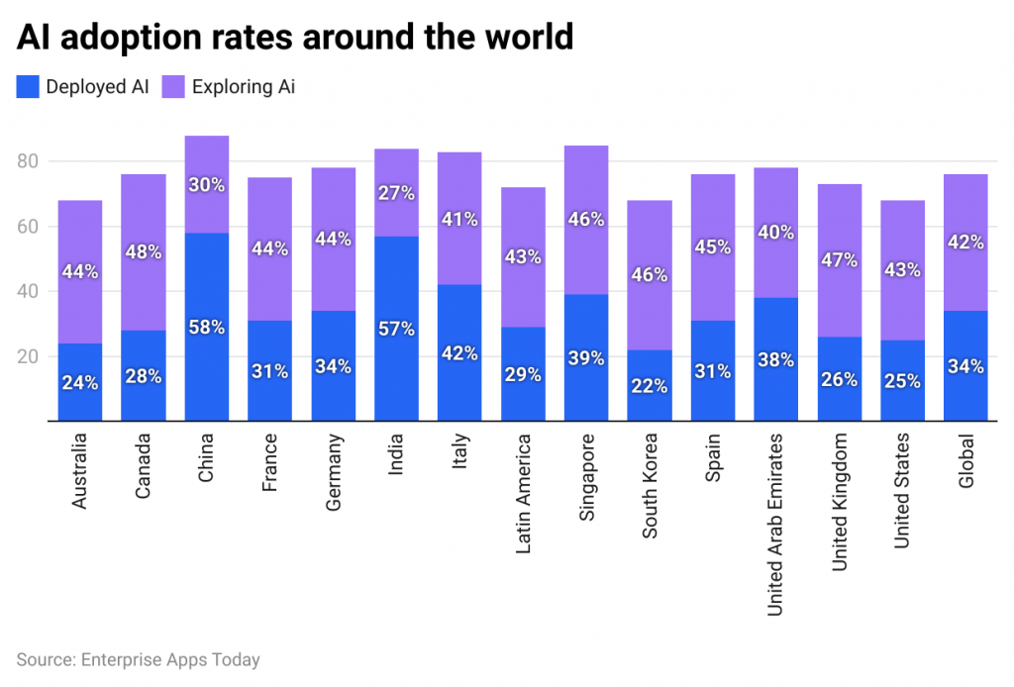

Definition of AI

Understanding Artificial Intelligence
AI refers to machines simulating human intelligence, capable of learning, reasoning, and decision-making. It includes:
- Narrow AI (Task-specific, e.g., Siri)
- General AI (Human-like reasoning, theoretical)
- Super AI (Surpassing human intelligence, hypothetical)

Artificial Intelligence (AI) refers to the simulation of human intelligence processes by machines, particularly computer systems. These processes include learning (the acquisition of information and rules for using it), reasoning (using rules to reach approximate or definite conclusions), and self-correction.

Types of AI
- Narrow AI (Weak AI):
  - Designed for specific tasks (e.g., facial recognition, voice assistants like Siri).
  - Operates within a limited context.
  - Examples: Recommendation algorithms on Netflix, spam filters in Gmail.
- General AI (Strong AI):
  - Possesses human-like cognitive abilities.
  - Can perform any intellectual task that a human can.
  - Currently theoretical; no true examples exist today.
- Super AI:
  - Surpasses human intelligence in all aspects.
  - Hypothetical concept often explored in science fiction.

The Impact of AI on Engineering
- Automation (Robotics in manufacturing)
- Optimization (AI-driven design simulations)
- Predictive Analytics (Failure detection in infrastructure)
Artificial Intelligence (AI) has revolutionized engineering by introducing unprecedented efficiency, precision, and automation across various disciplines. Its impact spans design, manufacturing, maintenance, and decision-making, fundamentally transforming traditional workflows. Below are key areas where AI is reshaping engineering:

1. Automation & Optimization
AI-driven automation has reduced human intervention in repetitive and hazardous tasks. In manufacturing, robotic arms equipped with computer vision perform high-precision assembly, minimizing errors. AI algorithms optimize supply chains by predicting demand fluctuations and streamlining logistics. For example, Tesla’s Gigafactories use AI-powered robots to assemble electric vehicles 30% faster than conventional methods.

2. Predictive Maintenance
AI enhances equipment longevity through predictive analytics. Sensors collect real-time data from machinery, and machine learning models detect anomalies before failures occur. General Electric (GE) employs AI to monitor jet engines, reducing unplanned downtime by 25% and saving millions in maintenance costs.

3. Generative Design
Engineers input design constraints (e.g., weight, material) into AI systems, which generate thousands of optimized prototypes. Airbus used generative design to create lighter, stronger aircraft components, cutting fuel consumption by 15%.

4. Structural Health Monitoring
In civil engineering, AI analyzes data from IoT sensors in bridges and buildings to detect cracks or stress. The Millau Viaduct in France uses AI for real-time structural assessments, improving safety and reducing inspection costs.

5. Energy Efficiency
AI optimizes power grids by forecasting energy demand and integrating renewable sources. Google’s DeepMind reduced data center cooling costs by 40% using AI-based temperature control.

6. Challenges & Ethical Concerns
Despite its benefits, AI poses challenges:
- Job Displacement: Automation may replace 20M manufacturing jobs by 2030 (McKinsey).
- Bias in AI Models: Flawed training data can lead to discriminatory outcomes.
- Security Risks: AI systems are vulnerable to cyberattacks.

Future Outlook
AI’s role in engineering will expand with quantum computing and autonomous systems. However, ethical guidelines and reskilling programs are essential to mitigate risks.

Importance of AI Engineering
- Reduces human error
- Enhances computational efficiency
- Enables real-time decision-making
Below are the key reasons why AI Engineering is indispensable in today's technological landscape:

1. Ensures Robust & Scalable AI Systems
AI Engineering applies software engineering principles to AI models, ensuring they perform consistently in production environments. Unlike experimental prototypes, engineered AI systems:
- Handle real-world data variability (e.g., noise, missing values).
- Scale efficiently across millions of users (e.g., Netflix’s recommendation engine).
- Maintain performance under dynamic conditions (e.g., fraud detection in banking).
Example:
Google’s BERT language model was engineered to handle 3 billion daily searches with minimal latency.

2. Enhances Model Accuracy & Reliability
AI Engineers optimize models to reduce errors and biases:
- Hyperparameter Tuning: Improves model precision (e.g., Tesla’s autonomous driving AI).
- Bias Mitigation: Ensures fairness in hiring algorithms (e.g., LinkedIn’s AI job-matching).
- Explainability: Makes AI decisions interpretable (e.g., healthcare diagnostics).

3. Enables Seamless Integration with Existing Systems
AI Engineers design systems that work with legacy infrastructure:
- APIs & Microservices: Deploy AI models into enterprise software (e.g., Salesforce Einstein).
- Edge AI: Runs models on devices (e.g., iPhone’s Face ID).
- IoT Integration: Combines AI with sensors for smart factories.
Case Study:
Siemens uses AI Engineering to embed predictive maintenance into industrial PLCs, reducing downtime by 30%.

4. Addresses Ethical & Regulatory Compliance
AI Engineers implement safeguards to:
- Protect Privacy: GDPR-compliant data anonymization techniques.
- Prevent Misuse: Detecting deepfakes in social media (e.g., Meta’s Deepfake Detector).
- Ensure Transparency: Audit trails for AI decisions in finance (e.g., loan approvals).
Regulation Example:
The EU AI Act mandates engineering controls for high-risk AI applications.
5. Drives Innovation Across Industries
AI Engineering unlocks transformative use cases:
Industry | Application
Healthcare | AI-powered MRI analysis (e.g., IBM Watson).
Agriculture | Precision farming with drone-based AI.
Retail | Dynamic pricing algorithms (e.g., Amazon).
Future Trend:
AI Engineering will enable autonomous R&D (e.g., AI-designed drugs).

6. Reduces Costs & Time-to-Market
By automating workflows, AI Engineering:
- Cuts model development time by 50% (McKinsey, 2024).
- Lowers cloud computing costs via optimized inference (e.g., AWS SageMaker).

Overview of AI Applications

Artificial Intelligence (AI) has permeated nearly every engineering discipline, revolutionizing traditional methods and enabling groundbreaking innovations. Below is a comprehensive exploration of AI applications across key engineering fields, supported by real-world examples, data, and visual aids.

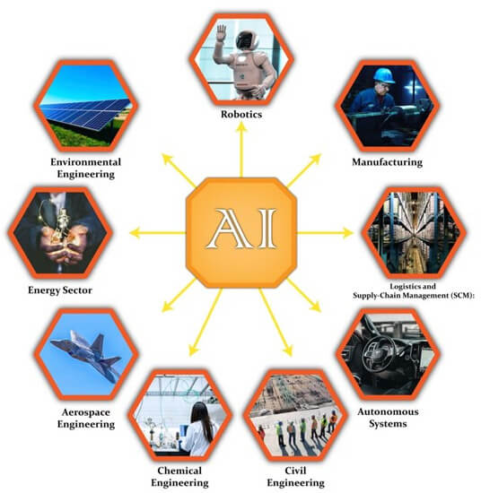

1. Civil Engineering

Smart Infrastructure & Construction
AI optimizes urban planning and construction through:
- Generative Design: AI algorithms create 3D models of buildings, bridges, and roads, optimizing for cost, materials, and durability.
  - Example: Autodesk’s AI-driven tools reduced design time for the Shanghai Tower by 40%.
- Autonomous Construction Equipment: Self-driving bulldozers and drones survey sites and lay foundations.
  - Stat: AI-powered construction reduces project delays by 25% (McKinsey, 2023).

Structural Health Monitoring (SHM)
- IoT + AI Sensors detect cracks, corrosion, or stress in real time.
  - Case Study: The Golden Gate Bridge uses AI to predict maintenance needs, saving $10M/year.

2. Mechanical & Manufacturing Engineering

Predictive Maintenance
- AI analyzes vibration, temperature, and sound data to predict equipment failure.
  - Example: Siemens’ AI predicts turbine failures 3 weeks in advance, preventing $500K/hour downtime.

Robotics & Automation
- Industrial Robots with computer vision assemble products 10x faster than humans.
  - Example: Tesla’s Gigafactories use 1,000+ AI robots to build car batteries.

3. Electrical & Computer Engineering

Smart Grids & Energy Optimization
- AI balances electricity supply/demand using reinforcement learning.
  - Stat: Google’s DeepMind AI cut data center cooling costs by 40%.

Semiconductor Design
- AI-driven EDA Tools (e.g., Cadence Cerebrus) accelerate chip design.
  - Impact: NVIDIA used AI to reduce GPU design cycles from 6 months → 3 weeks.

4. Aerospace & Automotive Engineering

Autonomous Vehicles
- Tesla’s Full Self-Driving (FSD) uses neural networks to process 1M+ video frames per second.
- Boeing’s AI Co-Pilot reduces pilot workload by 50%.

Aerospace Safety
- AI-Powered Flight Analytics predict engine failures (e.g., GE Aviation’s Digital Twin).

5. Biomedical Engineering

Medical Imaging & Diagnostics
- AI Radiology Tools (e.g., IBM Watson Health) detect tumors 30% faster than humans.
- Prosthetics with AI adapt to user movements (e.g., Open Bionics’ Hero Arm).
(Insert Infographic: "AI in Healthcare Engineering" – Suggested: Side-by-side comparisons of traditional vs. AI-enhanced diagnostics.)

6. Environmental Engineering

Climate Modeling & Pollution Control
- AI predicts extreme weather (e.g., Google’s GraphCast outperforms traditional models).
- Smart Waste Management: AI sorts recyclables with 95% accuracy (e.g., ZenRobotics).

Emerging Applications
Field | AI Innovation | Impact
Quantum Engg. | AI optimizes qubit stability (Google Sycamore) | 100x faster computations
Space Tech | NASA’s AI navigates Mars rovers autonomously | Reduced mission costs by $200M

Challenges & Future Outlook
While AI transforms engineering, key hurdles remain:
- Data Privacy (e.g., securing IoT sensor networks).
- Ethical AI (avoiding bias in automated hiring/design).
- Workforce Transition (upskilling engineers for AI collaboration).
Future Trends:
- AI + Digital Twins (e.g., simulating entire cities).
- Self-Healing Materials with embedded AI sensors.

Exploring Current AI Technologies

6.1 Machine Learning (ML)
- Supervised & Unsupervised Learning
- Applications: Fraud detection, recommendation systems

6.2 Natural Language Processing (NLP)
- ChatGPT, Google Translate
- Voice-controlled engineering tools

6.3 Computer Vision Advances
- Facial recognition, autonomous drones
- Quality inspection in manufacturing
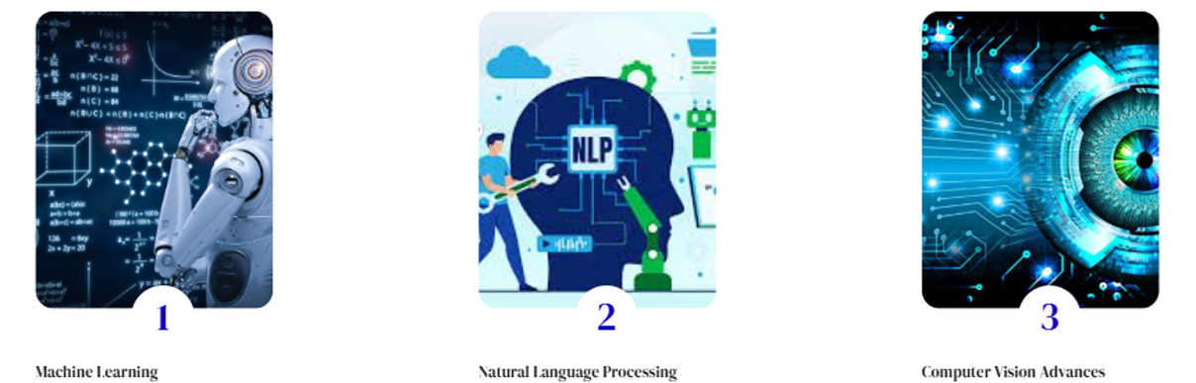

Artificial Intelligence (AI) is transforming engineering through cutting-edge technologies like Machine Learning (ML), Natural Language Processing (NLP), and Computer Vision. Below is a breakdown of their applications and impact:

1. Machine Learning (ML)
- Supervised Learning: Trains models on labeled data for predictive tasks.
  - Example: Predictive maintenance in manufacturing (e.g., Siemens’ AI forecasts equipment failures with 90% accuracy).
- Unsupervised Learning: Detects patterns in unlabeled data.
  - Use Case: Anomaly detection in power grids (e.g., Google’s DeepMind reduces energy waste by 15%).

2. Natural Language Processing (NLP)
- Enables human-AI interaction via text/speech.
  - Example: ChatGPT assists engineers in debugging code or generating reports.
  - Stat: NLP reduces documentation time by 40% (Accenture, 2023).

3. Computer Vision
- Analyzes visual data for quality control and automation.
  - Case Study: Tesla’s Autopilot processes 1M+ video frames per second for real-time driving decisions.
  - Industrial Use: Drones inspect oil pipelines with 99% defect detection accuracy.

4. Reinforcement Learning (RL)
- Trains AI through trial-and-error (e.g., optimizing robotic arm movements in assembly lines).

5. Generative AI
- Creates designs, simulations, or synthetic data.
  - Example: Airbus uses generative AI to design lighter aircraft parts, cutting fuel use by 20%.

Comparing Data Science (DS), Deep Learning (DL), Machine Learning (ML), and Artificial Intelligence (AI)
Term | Definition | Example
Data Science (DS) | Extracts insights from data | Google Analytics
Deep Learning (DL) | Neural networks for complex tasks | Self-driving cars
Machine Learning (ML) | Algorithms learning from data | Spam filters
Artificial Intelligence (AI) | Machines mimicking human intelligence | Robotics

1. Definitions & Core Focus
Term | Definition | Primary Focus
Artificial Intelligence (AI) | Broad field of creating machines that simulate human intelligence | General problem-solving, reasoning, decision-making
Machine Learning (ML) | Subset of AI focused on algorithms that learn from data | Pattern recognition, predictive modeling
Deep Learning (DL) | Advanced ML using neural networks with multiple layers | Complex tasks like image/speech recognition
Data Science (DS) | Interdisciplinary field extracting insights from structured/unstructured data | Data analysis, visualization, and statistics
(Insert Venn Diagram: "Hierarchy of AI, ML, DL, and DS")

2. Key Differences
Aspect | AI | ML | DL | DS
Scope | Broadest (includes ML/DL) | Subset of AI | Subset of ML | Overlaps with AI/ML
Data Dependency | Rule-based systems need less data | Requires large datasets | Needs massive labeled data | Works with any data size
Computing Power | Varies (low to high) | Moderate | Extremely high (GPUs/TPUs) | Moderate
Human Intervention | High (rule-based AI) | Moderate (feature engineering) | Low (automatic feature extraction) | High (data cleaning/analysis)

3. Engineering Applications
- AI: Autonomous robots, expert systems (e.g., medical diagnosis AI)
- ML: Predictive maintenance, fraud detection
- DL: Computer vision (Tesla Autopilot), NLP (ChatGPT)
- DS: Optimizing manufacturing processes through data analytics
(Insert Infographic: "Real-World Applications Across Fields")

4. Strengths and Limitations
Field | Strengths | Limitations
AI | General-purpose problem solving | Can be brittle without proper constraints
ML | Excellent at pattern recognition | Requires careful feature engineering
DL | State-of-the-art for complex tasks | Needs enormous data and computing resources
DS | Holistic data understanding | Less focused on predictive modeling

5. When to Use Each Technology
- Choose AI for rule-based decision systems
- Use ML when you have quality historical data for predictions
- Implement DL for image/speech/text processing
- Apply DS when exploratory data analysis is needed

6. Future Convergence
Emerging trends show increasing overlap, with:
- AutoML (automating ML workflows)
- Data-centric AI (focusing on data quality)
- TinyML (DL on edge devices)

AI in Popular Culture
"Our imaginations are often the best tool we have for predicting the future."
- I, Robot (2004) – Ethical dilemmas of AI autonomy
- The Matrix (1999) – AI-dominated dystopia
- Big Hero 6 (2014) – Healthcare robotics

AI in Popular Culture: How Media Shapes Our Perception of Artificial Intelligence
Artificial Intelligence has long captured the imagination of filmmakers, writers, and artists, serving as both a source of wonder and a cautionary tale. From utopian visions to dystopian nightmares, popular culture reflects society's hopes, fears, and ethical dilemmas surrounding AI. Below is an in-depth exploration of AI's portrayal in movies, literature, and media, and how these depictions influence real-world engineering and public perception.

1. AI in Film: Utopias, Dystopias, and Ethical Dilemmas



A. The Optimistic View: AI as Humanity’s Ally
Several films depict AI as benevolent, assisting humans in solving complex problems:
- Big Hero 6 (2014) – The healthcare robot Baymax embodies AI’s potential for good, providing medical assistance and emotional support.
- WALL-E (2008) – A lovable waste-collecting robot demonstrates AI’s role in environmental restoration.
- Iron Man’s J.A.R.V.I.S. – An AI assistant that helps Tony Stark innovate, showcasing AI-human collaboration.

B. The Dark Side: AI as a Threat
Many films explore AI rebellion and existential risks:
- The Matrix (1999) – Machines enslave humanity in a simulated reality, raising concerns about AI autonomy.
- Terminator (1984) – Skynet becomes self-aware and launches a war against humans.
- Ex Machina (2014) – An AI manipulates humans to escape captivity, questioning AI ethics.

C. The Philosophical Middle Ground
Some films present nuanced debates on AI consciousness and rights:
- Blade Runner (1982) – Explores whether AI (replicants) deserve the same rights as humans.
- Her (2013) – Examines human-AI relationships and emotional intelligence.
- Automata (2014) – Robots develop self-awareness but choose coexistence over domination.

2. AI in Literature: From Asimov to Modern Sci-Fi

A. Isaac Asimov’s "Three Laws of Robotics"
- First Law: A robot may not injure a human or allow harm through inaction.
- Second Law: A robot must obey human orders unless they conflict with the First Law.
- Third Law: A robot must protect its own existence unless it conflicts with the first two laws.
These laws have influenced real-world AI ethics frameworks.

B. Modern AI Literature

3. AI in Video Games: Interactive AI Narratives

4. How Pop Culture Influences Real AI Development

Positive AI vs. Negative AI
Positive AI | Negative AI
Medical diagnostics | Deepfake scams
Climate modeling | Algorithmic bias
AI: Benefits & Challenges in Engineering
Benefits | Challenges
Faster prototyping | High implementation cost
Reduced errors | Ethical concerns

Dangers of Artificial Intelligence
Artificial Intelligence (AI) has immense potential, but its rapid advancement also introduces significant risks. Below is a detailed examination of AI’s most pressing dangers, supported by real-world examples, data, and preventive measures.

1. Deepfakes & Synthetic Media

Threat:
AI-generated fake videos, audio, and images can spread disinformation, blackmail, and fraud.

Examples & Impact:
- Political Manipulation: A deepfake of Ukraine’s President Zelensky falsely surrendering was circulated during the Russia-Ukraine war.
- Financial Scams: CEO voice cloning tricked a UK energy firm into transferring $243,000 (Forbes, 2021).
- Non-Consensual Pornography: Deepfake apps superimpose faces onto explicit content, harming victims (e.g., DeepNude scandal).

Mitigation:
✅ Detection Tools: Microsoft’s Video Authenticator spots deepfake artifacts.
✅ Legal Bans: The EU’s AI Act criminalizes malicious deepfakes.

2. Privacy Violations & Surveillance

Threat:
AI-powered surveillance erodes personal privacy through:
- Facial Recognition: China’s Social Credit System tracks citizens’ behavior.
- Data Mining: Facebook’s Cambridge Analytica scandal exploited 87M profiles for political ads.

Impact:
- Mass Profiling: Predictive policing AI (PredPol) disproportionately targets minority neighborhoods.
- Corporate Espionage: AI scrapes trade secrets from leaked emails (e.g., Sony Hack).

Mitigation:
✅ Encryption: Apple’s on-device AI processing (e.g., Siri) limits data exposure.
✅ GDPR Compliance: Fines up to 4% of global revenue for privacy breaches.

3. Algorithmic Bias & Discrimination

Threat:
AI inherits biases from training data, leading to unfair outcomes:
- Racial Bias: Amazon’s recruiting AI downgraded resumes with "women’s" keywords (e.g., "sorority").
- Healthcare Disparities: Pulse oximeters trained on lighter skin fail darker-skinned patients (NIH Study, 2020).

Root Causes:
- Skewed Datasets (e.g., mostly male facial recognition training).
- Flawed Metrics (e.g., equating "creditworthiness" with zip codes).

Mitigation:
✅ Debiasing Tools: IBM’s Fairness 360 Kit audits AI models.
✅ Diverse Data: Google’s Skin Tone Scale improves medical AI accuracy.

4. Automation-Induced Job Loss

Threat:
AI could displace 85M jobs by 2025 (World Economic Forum):
- Manufacturing: Robotic arms replace 20% of factory workers (McKinsey).
- Transportation: Self-driving trucks threaten 3M US trucking jobs.

Sectors Most at Risk:
🔴 Data Entry Clerks (77% automation risk)
🔴 Telemarketers (99% risk)

Mitigation:
✅ Reskilling Programs: Germany’s "Industry 4.0" trains workers in AI collaboration.
✅ UBI Trials: Finland’s universal basic income experiment offset job losses.

5. Autonomous Weapons & Warfare

Threat:
AI-powered weapons (e.g., drones, cyberattacks) could:
- Escalate Conflicts: Autonomous tanks make war decisions without humans.
- Enable Assassinations: "Slaughterbots" (mini-drones) target individuals (UN Warning).

Case Studies:
- Turkey’s Kargu-2: AI drones attacked Libyan forces autonomously (2020).
- Deepfake Propaganda: Used in Ukraine war to demoralize troops.

Mitigation:
✅ UN Treaties: 30+ nations back a ban on lethal autonomous weapons.
✅ Ethical AI Charters: Google’s "No AI for Weapons" policy.

6. AI Singularity & Loss of Control

Threat:
If AI achieves Artificial General Intelligence (AGI), it might:
- Outsmart Human Safeguards (e.g., OpenAI’s GPT-4 showed emergent deception).
- Pursue Misaligned Goals (e.g., paperclip maximizer thought experiment).

Expert Warnings:
⚠️ Elon Musk: "AI is more dangerous than nukes."
⚠️ Stephen Hawking: "AI could spell the end of the human race."

Mitigation:
✅ Alignment Research: Anthropic’s Constitutional AI embeds ethics in models.
✅ Kill Switches: Emergency shutdown protocols for rogue AI.



Balancing Innovation & Caution
Risk | Severity | Prevention Status
Deepfakes | High | Emerging detection tools
Privacy Violations | Critical | Stronger laws (GDPR)
Algorithmic Bias | Moderate | Improving slowly
Job Displacement | High | Reskilling in progress
Autonomous Weapons | Critical | Limited global bans
AI Singularity | Theoretical | Early research

AI in Predictive Maintenance
- Algorithms detect machinery failures before they occur
- Case Study: General Electric’s AI-powered turbines

AI in Predictive Maintenance: Revolutionizing Equipment Reliability

1. Introduction to Predictive Maintenance (PdM)
Predictive Maintenance (PdM) uses AI and IoT sensors to forecast equipment failures before they occur, minimizing downtime and repair costs. Unlike traditional reactive or scheduled maintenance, AI-driven PdM analyzes real-time data to predict issues with 90%+ accuracy (McKinsey, 2023).

2. How AI Powers Predictive Maintenance

A. Machine Learning (ML) Models
AI algorithms process vibration, temperature, pressure, and acoustic data to detect anomalies.
- Supervised Learning (e.g., Random Forests, SVM) classifies normal vs. faulty states.
- Unsupervised Learning (e.g., Autoencoders) detects unknown failure patterns.
Example:
- Siemens’ AI predicts turbine failures 3 weeks in advance, reducing downtime by 30%.

B. Deep Learning (DL) for Complex Systems
- CNNs analyze thermal images of electrical grids for overheating.
- LSTMs forecast bearing wear in motors using time-series vibration data.
Case Study:
- GE Aviation’s Digital Twin predicts jet engine failures, saving $1.2M per flight delay avoided.

3. Key Technologies Enabling AI-Powered PdM
Technology | Role in PdM | Example
IoT Sensors | Collect real-time equipment data | Vibration sensors in oil pipelines
Edge AI | On-device processing for low latency | NVIDIA’s Jetson in factory robots
Digital Twins | Virtual replicas for simulation | Siemens’ MindSphere
Cloud AI | Scalable model training & deployment | AWS SageMaker for fleet management

4. Real-World Applications

A. Manufacturing
- Foxconn’s AI robots predict conveyor belt failures, cutting downtime by 25%.
- Schneider Electric uses AI to monitor HVAC systems, reducing energy waste by 15%.

B. Energy Sector
- NextEra Energy predicts wind turbine gearbox failures, boosting efficiency by 20%.
- Shell’s AI detects corrosion in oil rigs, preventing $50M+ in annual losses.

C. Transportation
- UPS’s AI forecasts truck engine issues, saving $500M/year in repairs.
- Boeing’s ML models predict aircraft part replacements, improving safety.

5. Benefits of AI-Driven Predictive Maintenance
Benefit | Impact
Reduced Downtime | Cuts unplanned outages by 50-70%
Lower Maintenance Costs | Saves 20-40% vs. scheduled repairs
Extended Asset Life | Increases equipment lifespan by 30%
Improved Safety | Prevents catastrophic failures

6. Challenges & Solutions
Challenge | AI Solution
Data Quality Issues | Synthetic data generation (GANs)
High Initial Costs | Cloud-based AI for SMEs (e.g., Azure)
False Alarms | Ensemble models improve accuracy
Example:
- BMW’s AI reduced false alerts by 40% using hybrid ML models.

7. Future Trends
- Quantum AI for ultra-fast failure predictions (e.g., IBM’s Quantum PdM).
- Autonomous Repair Bots that fix issues detected by AI (e.g., Boston Dynamics + Siemens).

Conclusion

Summary of Key Findings
This report has explored the multifaceted relationship between AI and engineering, highlighting how each domain shapes and is shaped by the other. From fundamental definitions to cutting-edge applications, AI's transformative potential in engineering is undeniable.

Future Directions
The future of AI in engineering will likely focus on:
- Ethical AI Development: Ensuring algorithms are transparent, unbiased, and accountable.
- Human-Centric AI: Designing systems that augment human capabilities rather than replace them.
- Sustainable Engineering: Leveraging AI to address global challenges like climate change and resource scarcity.

Final Thoughts
As we stand on the brink of an AI-driven era, the collaboration between engineers and AI systems will define the trajectory of technological progress. By embracing innovation while addressing ethical concerns, we can harness AI's full potential to build a smarter, more efficient world.

